|  |
| --- |
| DATE. : 20-11-2022 |
| TEAM ID : PNT2022TMID42931 |
| PROJECT NAME. : SMART WASTE MANAGEMENT SYSTEM FOR METROPOLITIAN CITIES |

UAT INITIATION AND DESIGN

index.py

import http.client

conn=http.client.HTTPSConnection("spoonacular-recipe-food-nutrition-v1.p.rapidapi.com") headers = {

'X-rapidapi-host': "spoonacular-recipe-food-nutrition-v1.prapidapi.com"

'X-repidapi-key": "93706b4a26msh70946cd35d92e9bp1ea5755fb7b705b36"

}

conn.request("GET", "/recipes/guessNutrition?title=cereal", headers) res = conn.getresponse{} data=res.read{} print[data.decode{"utf-8"}]

RAPID API :

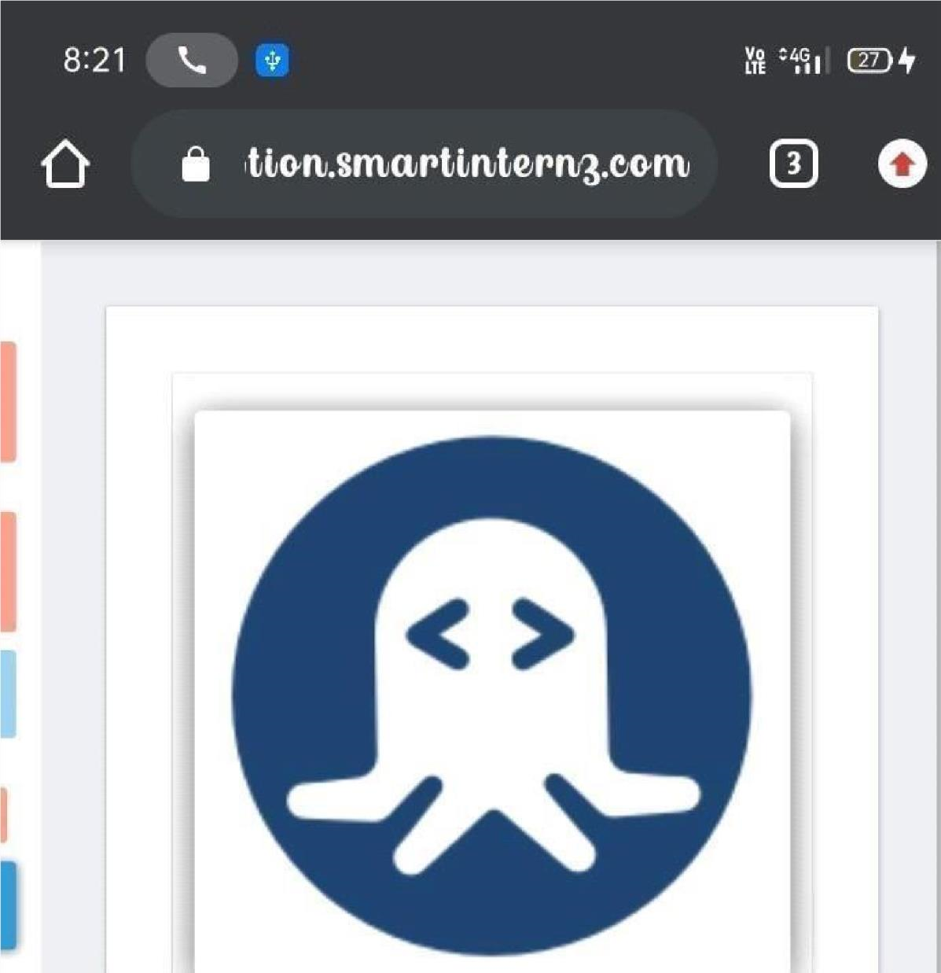

EXAMPLE :

